Puerto Galera is well known for its beaches, like the White beach and the Sabang beach. For some these two are the most popular Puerto Galera beaches in Oriental Mindoro here in the Philippines.
But aside from this two there’s actually a lot more of Puerto Galera or should I say Oriental Mindoro beaches that others don’t know about or talk about very often.
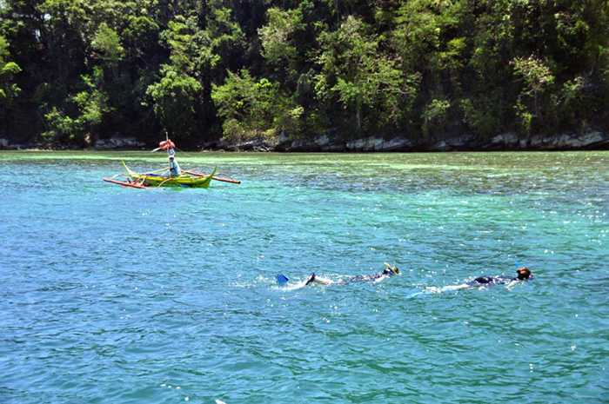
There’s at least 20 Puerto Galera beaches surrounding the island of Mindoro where Puerto Galera is located.
Here we will go through the list of all Puerto Galera beaches that you can enjoy on your next holiday here.

Puerto Galera Beaches
- Small Tabinay Beach
- White Beach
- Haligi Beach
- Aninuan Beach
- Tamaraw Beach
- Sabang Beach
- Big La Laguna Beach
- Small La Laguna Beach
- Sinandigan Beach
- Bayanan Beach
- Balatero Beach
- Encenada Beach
- Dalaruan Beach
- Dulangan Beach
- Hundura Beach
- Minolo Beach
- Balete Beach
- Palangan Beach
- Bulabod Beach
- Talipanan Beach

Small Tabinay Beach
10 minutes away from Muelle pier you’ll be in Small Tabinay Beach. Tabinay beach is one of the peaceful beach in Puerto Galera and this is where you’ll find the BADLADZ Beach Resort.
From the resort you’ll have a stunning view of the ocean, you can lie down on one of the hammocks tied up on the coconut trees along the beach and enjoy the beautiful sky.
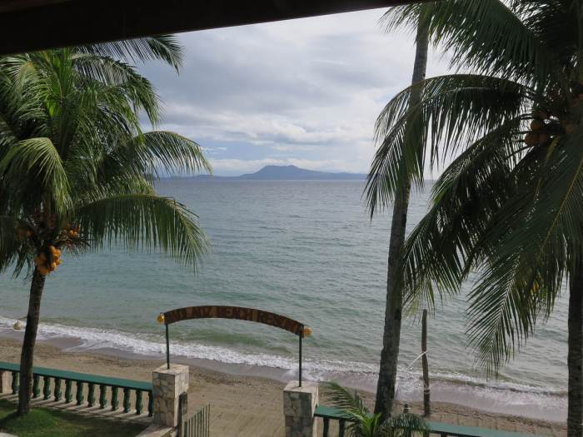
The stillness of the water will eventually tempt you to swim. If you haven’t been in this place, it’s never too late to check it out.
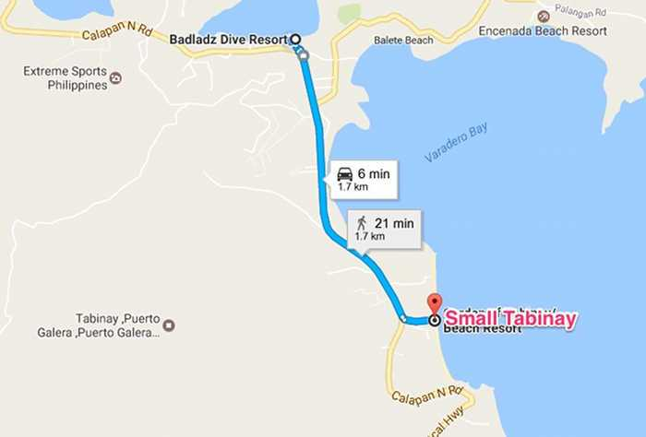
The sunrise comes out in the morning directly in front of the resort over the water. The sunset goes down over the mountain behind the resort and sometimes offers some beautiful pink sky.

White Beach
Some people say White Beach is the most popular of all the Puerto Galera beaches. Because of the smooth white sand and it’s beautiful beach some also call it the “Small Boracay”. From BADLADZ you can be at the beach within 20 minutes.
If you’re coming from Batangas Port you can go directly to the White beach since this is also one of the piers in Puerto Galera.
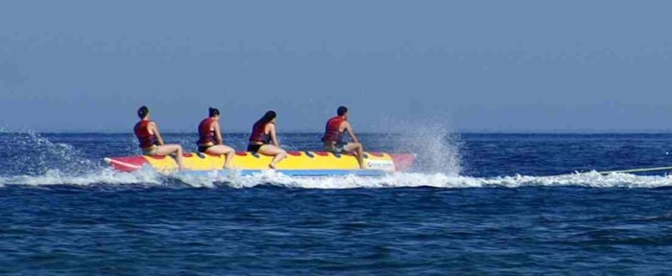
During the day White beach is a place for a lot of water activities, some of them are;
- Swimming
- Snorkeling
- Scuba diving
- Jet skis
- Banana boats
- Kayaking
- Parasailing
- Sailing
Besides these activities offshore, there are also a lot more to enjoy onshore. From the hotels, international restaurants, souvenir shops, henna tattoo shops, bars and many more. There is a lot happening on this beach which makes it a great place to visit on a day trip from BADLADZ.

When the night comes the bars and restaurant areas come alive with people relaxing having food and a few cold drinks. There are several small bars and restaurants to choose from.You can also take your drink to go and have a stroll along the beach, enjoying various shows, fire dancers, and the unique sights and sounds of White Beach.
When you are in Puerto Galera, I suggest that you have this place in your itinerary for a day trip. Keep in mind during peak seasons this beach can be very busy. That’s why a lot of our guests stay with us as they are not in the overcrowded areas and enjoy more space to move about.
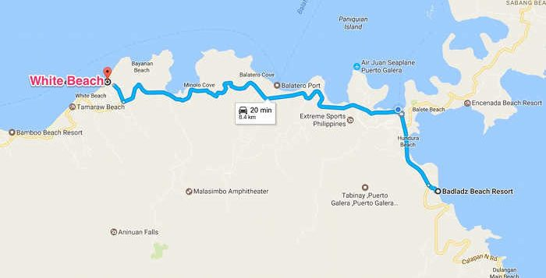

Haligi Beach
Haligi Beach is located on an island near Puerto Galera, from the White beach it will be a 20 mins boat ride to the beach.
The fine white sand and the crystal clear water will satisfy you upon reaching this beach. Perfect for swimming and snorkeling in any direction and fun for collecting colored stones for souvenirs.
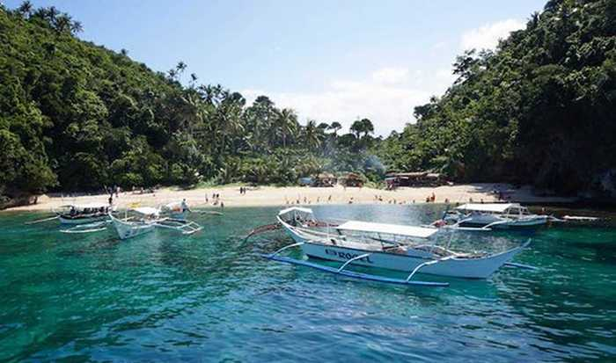
Diving deeper in the water will fascinate you even more, lots of star fish and other underwater creatures. Make sure to bring your underwater camera so you can take a picture or a video of this wonderful beach.
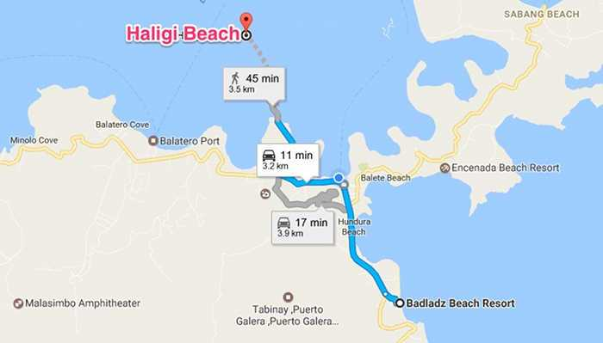

Aninuan Beach
Five minutes away from White beach is where you can see the Aninuan beach. After hiking from the Aninuan Falls come and visit the beautiful Aninuan beach. Compared to the other Puerto Galera beaches this one is more private.
You’ll have a peaceful moment while sitting down on the sand under the nipa huts while watching the waves laps on the shore.
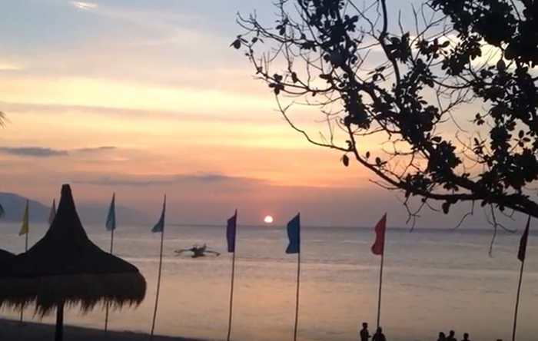
Watching the sunset from this beach is one of a kind, you should check this out on a day trip as well.
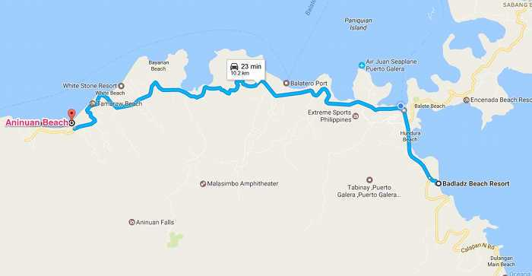

Tamaraw Beach
Walking distance away from the Aninuan Beach, Tamaraw Beach is another one of the peaceful Puerto Galera beaches you’ll see. In this area there’s not a bunch of hotels or even restaurants so in other words this place is not yet that popular.
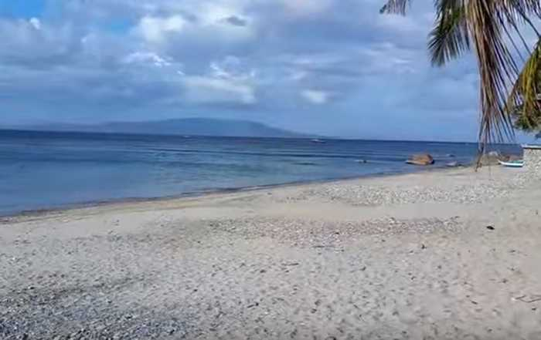
Because of this Tamaraw Beach is a wonderful place for lovers and families who want to be alone and just stroll on the beach while having the amazing view of the beach and the sunset.
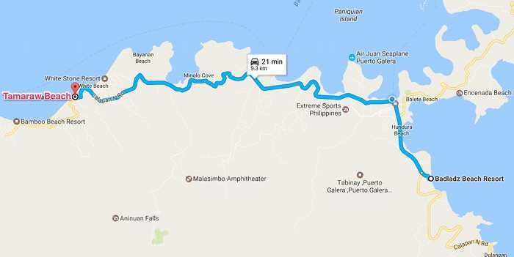

Sabang Beach
Second of the most popular beaches in Puerto Galera is Sabang Beach. This is one of the popular dive sites in Puerto Galera because of the beautiful Sabang Wrecks. BADLADZ Scuba Diving has dives available for beginners or professional divers to come here and dive these wrecks. They can also take you to all the dive sites in Puerto Galera.
Sabang Beach is also one of the piers of Puerto Galera so you’ll see a lot of banca boats on its bay as seen on the video above.
Since this is the second most popular as I’ve said this area has a lot of hotels, restaurants, shops, spa, 2 floating bars and several girly bars available for the wild ones. Easy to say that the fun for some starts when the sun goes down.
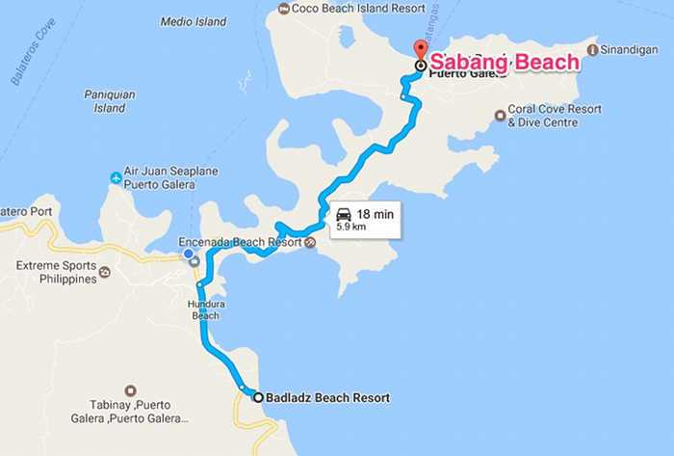
Nightlife in Sabang goes late in to the night. You’ll find most of the bars open until 12am or 2am and Big Apple stays open 24 hours a day. So if you want to party all night this place will not disappoint you.

Big La Laguna Beach
Big La Laguna Beach is located fifteen minutes away from Sabang Beach. This also one of the highly visited beaches in Puerto Galera. This is a perfect place to take a day trip as well. Some of the tourists also call Big La Laguna the “ Small Boracay “ because of the white sand covered with the crystal clear water.
The water on the beach is also one of the clearest so you can easily see the bottom. As you dive you’ll see a lot of fish and corals making it interesting to explore.
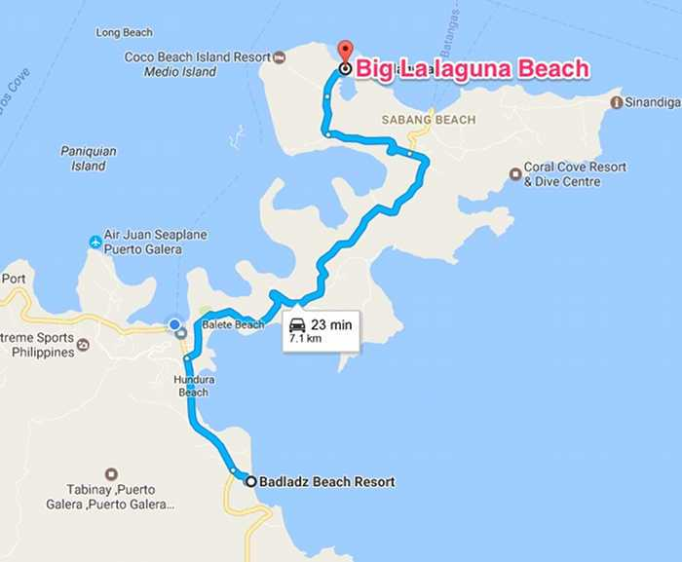

Small La Laguna Beach
Another one of the prime beaches in Puerto Galera is the Small La Laguna. Just a walking distance away from Sabang Beach you’ll see the beauty of the Small La Laguna.
You can enjoy a lot of water activities here the same as the other beaches, from kayaking, jet skiing, banana boat riding and windsurfing. This is truly a small paradise in Puerto Galera.
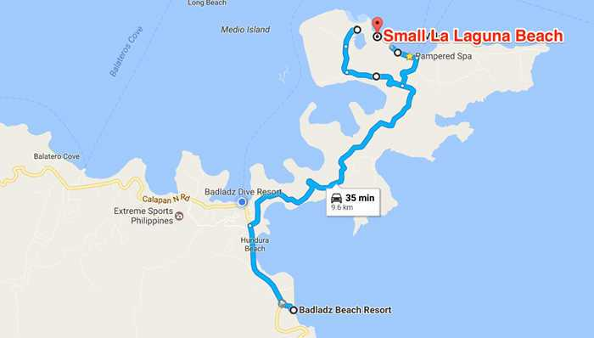

Sinandigan Beach
From Sabang it would take 11 minutes before you’ll be in Sinandigan Beach. Some of the known landmarks in the area are the Sinandigan Lighthouse and the amazing Sinandigan Wall.
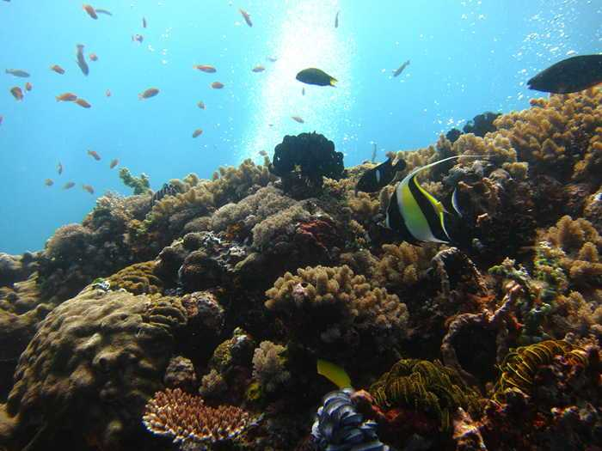
Sinandigan wall is the richest dive site in Puerto Galera from the beautiful corals to the abundant marine life and the different species of fish. This is a must visit place for all the divers out there.
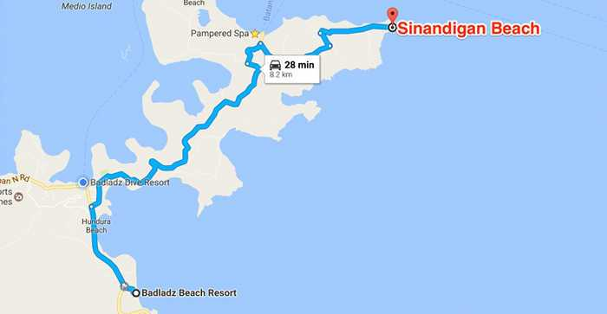

Bayanan Beach
Bayanan Beach is just on the other side of the White beach. Compared to the White Beach here you’ll find this untouched cool and clean beach and a lot of pebbles you can see here. Nice spot for snorkeling and kayaking.
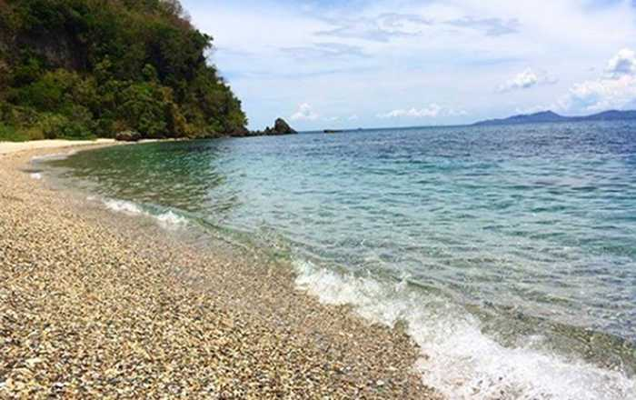
To go here you can walk from the White Beach in just 15 minutes walk or you can ride a banca boat so you can see the beauty of the whole bay. On the other hand if your staying at BADLADZ it will be a 20 minute ride from a local tricycle and you’ll be on the beach.
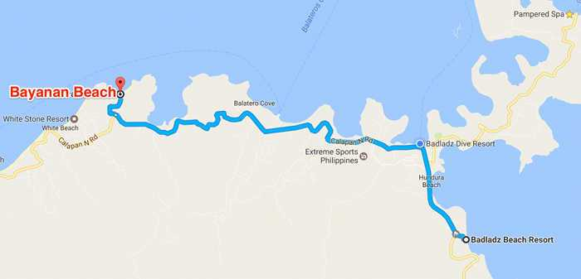

Balatero Beach
15 minutes away from BADLADZ Beach Resort and 8 minutes from our BADLADZ Dive Resortyou’ll find Balatero Beach. Combination of sand, water, trees and the blue skies Balatero Beach is a paradise.
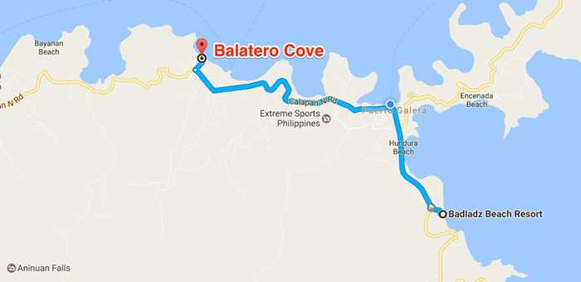
Swimming in Balatero Beach gives you the general feeling of freshness. An swimming excursion into the deeper parts will reveal some of the most amazing and dazzling fishes in the Philippines and the world.
Balatero beach will present you the opportunity to unwind and connect back to nature.

Encenada Beach
Another secluded beach you can visit in Puerto Galera is the Encenada beach. This beach is ideal for its peaceful surroundings and the great beach for relaxing. The crystal turquoise waters that welcomes you to dive in.
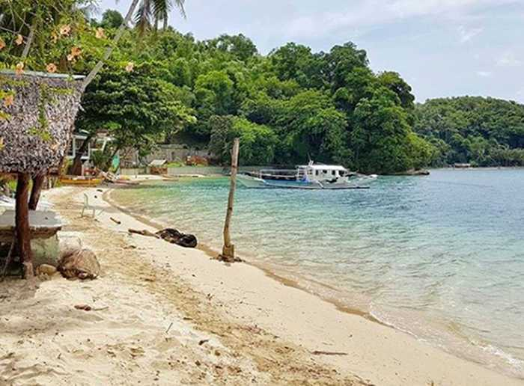
You can reach this beautiful beach within 10 minutes from Sabang by a local tricycle or a motorcycle.
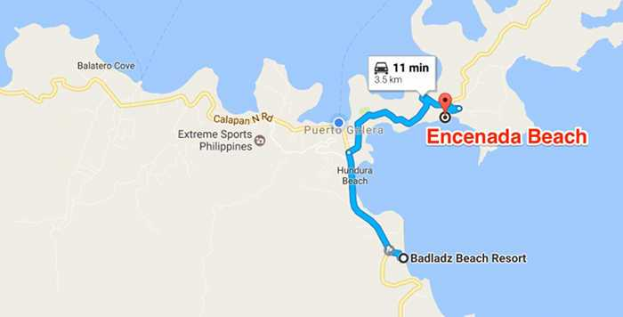

Dalaruan Beach
Dalaruan Beach is one of the most enjoyable in all Puerto Galera beaches. Same as the other beaches here you’ll see the sand pure and unspoiled, the fresh clear waters that brings breeze and gives you the refreshment you need.
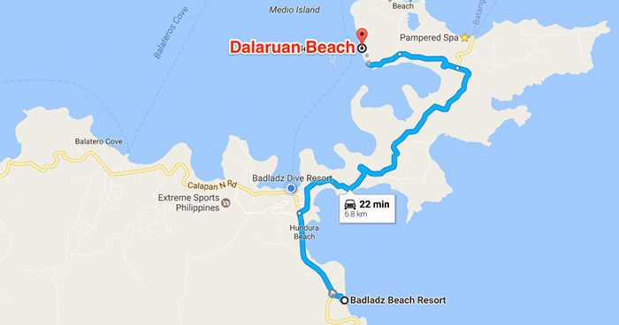
The beauty of the Dalaruan Beach extends to the depths of the water itself. There are coral reefs, triggerfish, tuna and other exotic and unique fish that live along the bay.

Dulangan Beach
Dulangan Beach is located near the Puerto Galera Town Center. It’s just a 9 minute ride in a local tricycle from BADLADZ and you’ll be in the beach.
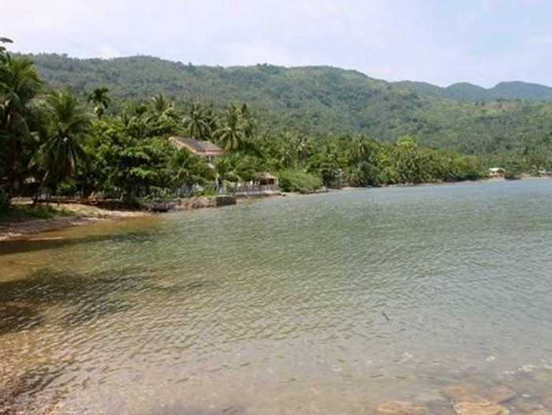
The sand, water, sky and air can ease and give you a sense of calm. You can take a morning walk along the beach and watch the sunrise.
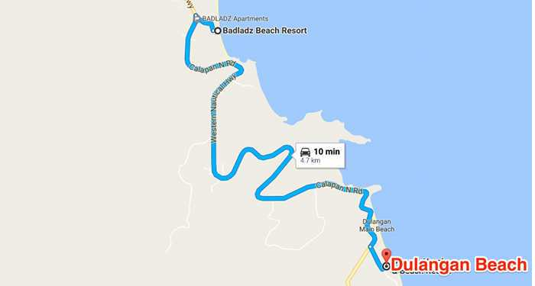
Dulangan Beach is one of the 20 Puerto Galera beaches you should never miss.

Hundura Beach
Hundura Beach or the Poblacion Beach is not that popular compared to the other beaches like the Sabang and the White beach. This beach isn’t really for visiting as there isn’t much beach front and isn’t very accessible due to businesses and private property on the beach front.
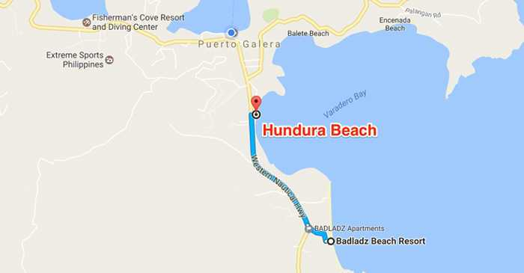

Minolo Cove
If you want a more private location, you can go to Minolo Cove. This is the place where you can have a time for yourself or with your special love ones.
Like the other beaches you can also enjoy swimming in the clear waters. While enjoying your swim below are plenty of fish and coral reefs to amaze you. You will also appreciate the spectacular scenery during nighttime.
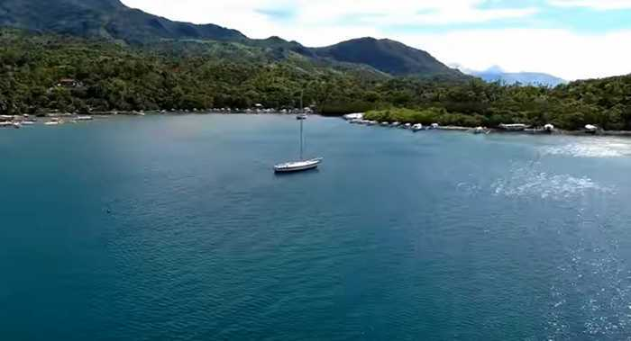
Listening to the waves, gazing at the stars and listening to the whispering wind is something that cannot be expressed by words and must be experienced.
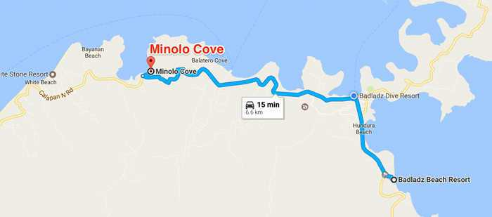

Balete Beach
Balete Beach is quite easy to get to, just a few minutes walk away from Muelle pier. Walk pass the church and turn left to the Municipality office, and instead of turning left to Sabang go straight. It will lead you directly to the Balete Beach.
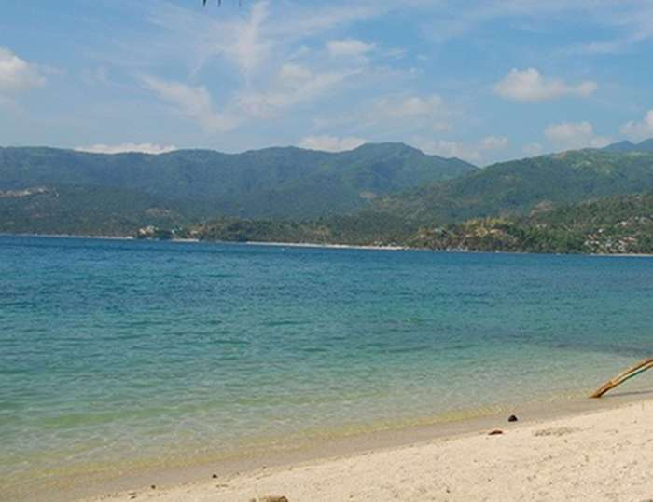
This beach is not yet developed to be a tourist spot but nevertheless its lack of development makes it perfect for some. Its a pleasant place for people who want to avoid the crowds and for those who would like to meet the locals of Puerto Galera.
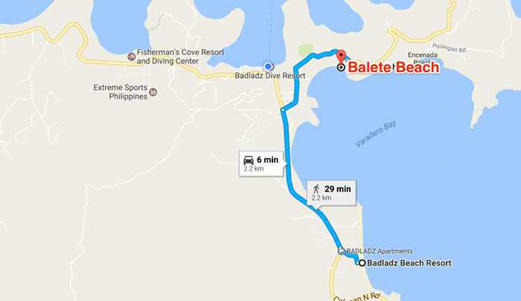

Palangan Beach
Another great day trip to the beach if you want a little break is visiting Palangan Beach. This is one of the best tourist spots here in Puerto Galera.
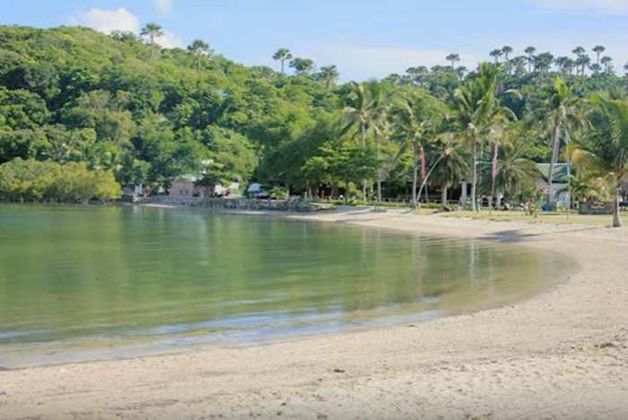
The cleanliness of the water offers an invitation for you to swim in Palangan Beach. A stunning view in any direction you look, beautiful sunrise and sunset view. Spending your vacation in Palangan Beach is an experience that you’ll not more likely forget anytime soon.
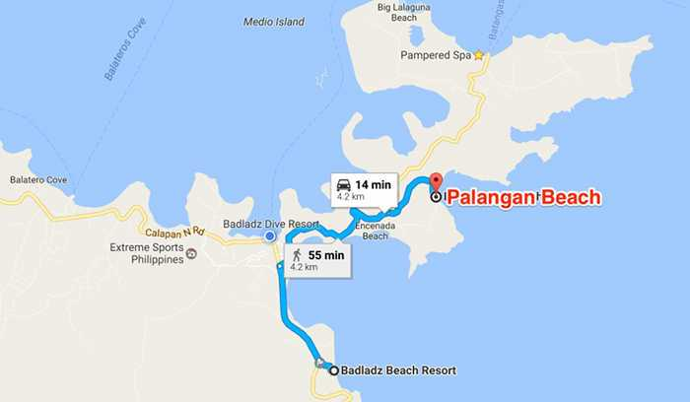

Bulabod Beach
Another beach that you must discover here in Puerto Galera is the Bulabod beach. Approximately 19 minutes away from BADLADZ Beach Resort, Bulabod beach is one of the secluded beaches that you’ll ever see in Puerto Galera.
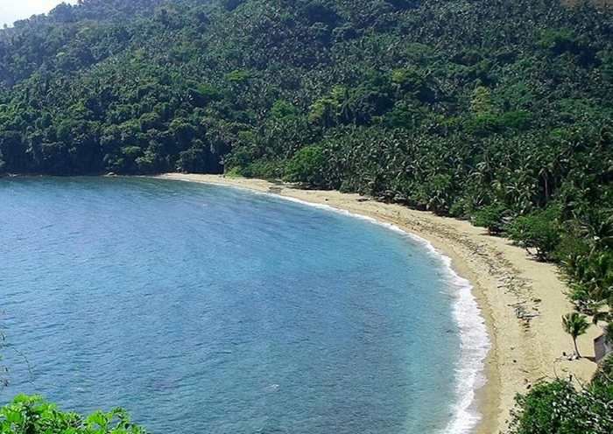
The water here in Bulabod Beach is refreshing and so clean and clear that you would easily see what is under it. The amazing thing here is that there’s a part of Bulabod Beach where the river is connecting from the mountain to the beach and the trees are surrounding it.
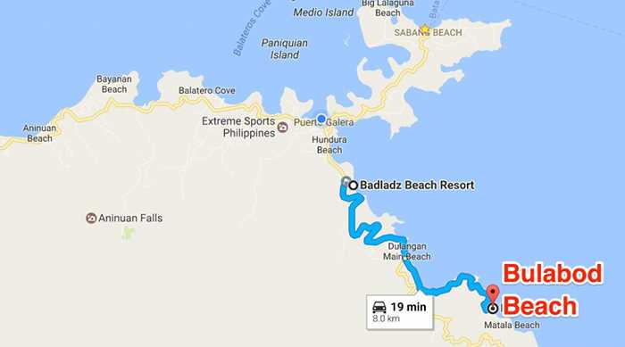
This is a perfect spot where you can swim and enjoy away from the heat of the sun.

Talipanan Beach
Getting to Talipanan beach will just be a 25 minutes ride from BADLADZ. First step at the beach you’ll have a direct view of the long white beach and crystal clear water. Perfect for water activities from swimming, snorkeling and many more.
On the other side you’ll see the beautiful tropical jungle and the mountain paradise.
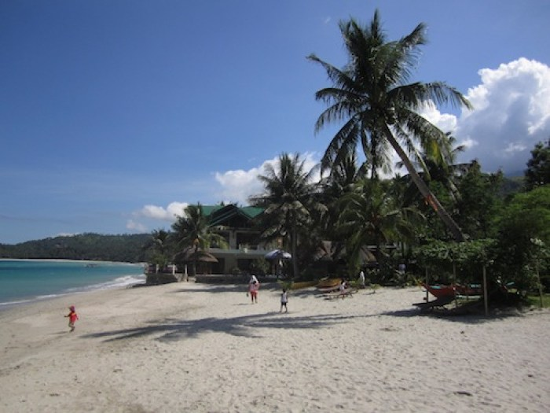
Talipanan Beach will provide an alternative to the crowded environment for those who are looking for a peaceful and quiet vacation.
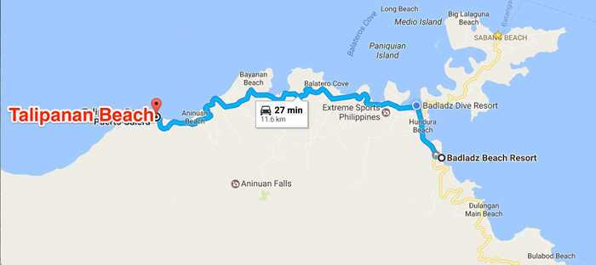
These are all the beaches you can visit here in Puerto Galera Oriental Mindoro. If you come and stay with us at any of the BADLADZ properties, we’ll help you find the Puerto Galera Beaches on our map.
Cheers,
Sean

Puerto Galera is just a small tourist spot resort but the people there are nice and very accommodating to their visitors. It is located on the northern part of Oriental Mindoro. From Manila , it is about 130 kilometers going to the south.
How to get there?
You can get a ride from Manila to Batangas City pier by private car or public transportation like a bus, and then from the pier, board a boat directly to Muelle, then from Muelle, there’s a short trip going to the resort.
Don’t worry, you will not get lost because the people are nice and can be trusted to help you.

